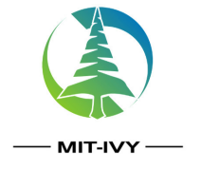 MIT-IVY INDUSTRY CO.,LTD
Block A 2212, Diamond International, Xuzhou City, Jiangsu Province, China
TEL: 0086-13805212761 FAX:0086-0516-83769139
WHATSAPP:0086-13805212761
EMAIL:INFO@MIT-IVY.COM
检验报告
CERTIFICATE OF ANALYSIS
品名Product | N-乙基苯胺  N-Ethylaniline
批号  Batch number | 202105297 | CAS No. | 103-69-5
包装  Package | 塑料桶  plastic barrel | 生产日期  Production Date | 2021.5.30
容量  Capacity |  | 检验日期  Inspection date | 2021.6.9
—

指标名称  The index name | 指标 |  |  | 分析结果  The results of the analysis
 | 优级品  Optimal grade | 一级品  First class | 合格品  Nonconforming product
外 观 | 无色至浅黄色透明液体，贮存时允许颜色变深  Colorless to light yellow transparent liquid, allowing the color to darken when stored |  |  | 透明液体  Transparent liquid
干 品 凝 固 点 ℃≥
Dry product setting point
N-乙基苯胺含量 %≥  N-Ethylaniline | 99.30 | 99.15 | 99.00 | 99.27
苯 胺 含 量 %≤  Benzene amine | 0.3 | 0.4 | 0.5 | 0.2
N，N-二乙基含量 %≤  N,N-Diethylaniline | 0.3 | 0.4 | 0.5 | 0.38
水 份 含 量 %≤  moisture capacity | 0.005 | 0.005 | 0.01 | 0.004
结 论  conclusion | 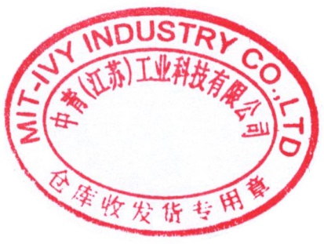  本批产品符合 一级 品  This batch of products conforms to the first grade
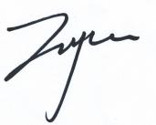 | 